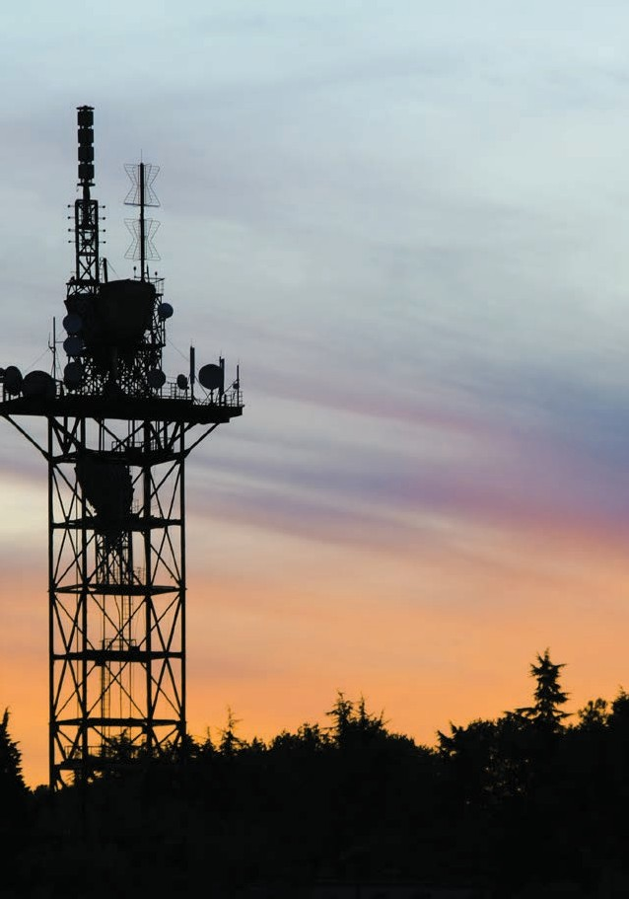

TELECOM
19 INCH RACK-MOUNT

INVERTERS

The pure sine wave DT-1000 Series inverters are BWITT new expand customize inverter. This Series is a professional 19” rack enclosure with a wide range of options to suit applications.

2RU RACK MOUNT

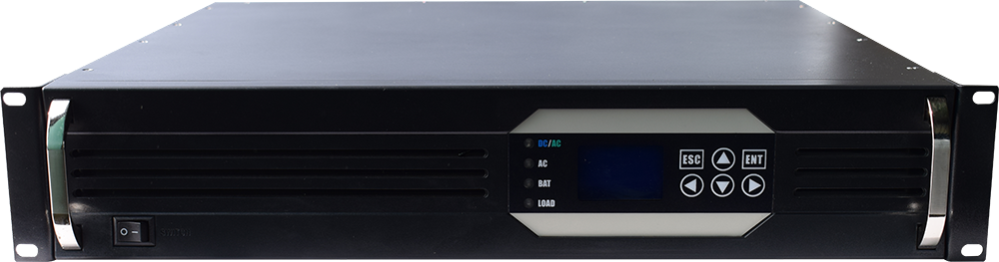
INVERTER
INPUT 110VDC

POWER 2400W/3000VA
OUTPUT 120VAC

Description

This type Rack mount Inverter with a new generation of dual input inverter solution designed for the field of communication applications, which is suitable for the high reliability of the communication system. The solution is equipped with 120V AC power supply and 110V DC power Input , which fills the gap between the traditional UPS power supply and common pure sine wave inverter solutions.
It uses a novel design structure that helps users to provide Pure, stable and durable AC power for critical loads, and has the same high reliability as the AC power supply system. The design characteristics of the dedicated communication pure sine wave inverter ensure the seamless conversion between the AC and DC power supply, almost no conversion delay, and build in the static switch.

Feature

- Standard 19” Rack mount2 RU Chassis;
- True sine wave output (T.H.D < 3%)；
- Large 128*64 digital Lcd display data information,4 led display working;
- 5 Routes Dry contact for system (DC input fault, AC input fault, overload information, by-pass information and output fault)；
- RS232 and RS485 & Optional SNMP communication Port；
- Power-on self-test, Soft output start,Start auto restart while Ac or Dc is recovering;
- Auto switch function: DC to AC, AC bypass, less than 5ms;
- Real-time monitoring of the system operating status,Audible and visual alarm;
- Record the historical alarm message and can be queried;
- Build in voltage regulator Stabilize AC voltage;
- Maintenance bypass /DC available;
- Protection :Short load protection, over load protection, battery over/under voltage protection, over current, over temperature;

Technical Data
Model | BWT110/120-3KVA
INPUT
AC Input Voltage | 98~144 VAC (120V _{Norm})
Battery Input Voltage | 110Vdc
Battery Voltage Range | 104Vdc—145Vdc
Cutoff Voltage | ＜90 or ＞150Vdc
Cooling | 4*Fans (Temp.Control Speed According to the output Capacity)
DC Input Current | 28.84 Max
Output Frequency | 60Hz±0.1%
PF | 0.8
OUTPUT
Output Capacity | 3000VA
Rated Output Capacity | 2400W
Rated output Voltage | 120VAC (Inverter Mode)
Rated Output Current | 20A
Output Voltage Range | 120Vac(Tolerance ±1.5% @Inverter Mode)
Output Efficiency | 85~90% (Inverter Mode)
Output Frequency | 60Hz
Frequency Range | 57~63Hz
Output Wave | Pure sine wave
THD | ≤3% (Line Load)
Switch Time (By pass to Inverter mode) | ≤5ms (With Load)
PROTECTIVE FEATURE
AC Under Voltage Switch Protection | ≤90Vac (Backlash voltage≥10Vac)
AC over Voltage Switch protection | ≥155AC
Over-Temperature | Yes (Auto Switch)
Battery under voltage protection point | ≤90
Battery Low-voltage alarm | 90±0.5
Battery overvoltage protection point | ≥155VDC
Battery overvoltage recovery point | ≥145VDC
Output Over Current Protection
Over Load Capacity | Continue working @overload 110%
Over Load Capacity | Continue working 60s @ overload 110%~130%
Over Load Capacity | Continue working 10s @over load >150%
Over Temp. Protection | Yes
short circuit Protection | Yes (Don’t test under AC Connect)
Reverse connection protection | Yes
Output OVP | ≥145VAC(Inverter Mode)
Output low voltage alarm | ≤90VAC (Inveter Mode)
SAFETY AND EMC
Dielectric strength（AC-Chassis） | 3500Vdc/10mA//1min .No flash over, no breakdown, no arc (Only AC Input priority)
Dielectric strength（DC-Chassis） | 750Vdc/10mA/1min. No flash over, no breakdown
LVD | EN 60950-1
EMC/EM I | EN 61000-6-3; EN 61000-6-1 ;IEC 61000-6-2 and IEC 61000-6-4
ROHS | IEC 62321-4 , IEC 62321-5,IEC 62321-6,IEC 62321-7,IEC 62321-8
ENVIRONMENT TEST PERFORMANCE
Ambient Temp. | -20~ +50℃
High temperature operation | 50±2℃ (rated load 24H)
Low temperature operation | -20±2℃ (rated load 24H)
High temperature storage | 80±2 ℃，24H
Low temperature storage | -40±2℃，24H
Humidity | 0~90%，No moisture condensation
Operating Altitude (m) | Altitude Full power up to 2000m.derating -2% / 100m, max altitude 5000m
COMMUNICATION
Rs232 & Rs485 | Yes
SNMP | Optional
Dry Contact | 5 group
LCD DISPLAY
LCD Status | Input and output Voltage, Frequency ,Output Current,Temp., Load Rate, LOGO etc.
Inverter Status | Normal Mains, Normal Inverter, Battery Under-voltage and output overload etc.
MEASUREMENT
Size W*D*H(mm) | 482*347*88
Weight | 13.5KG
Live Product

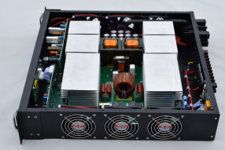
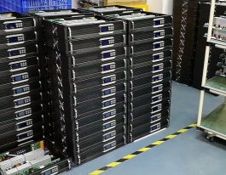
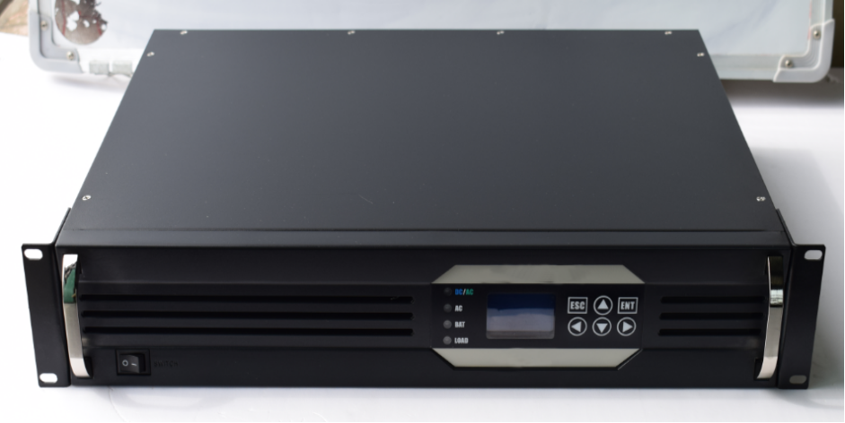
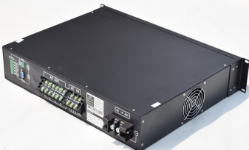

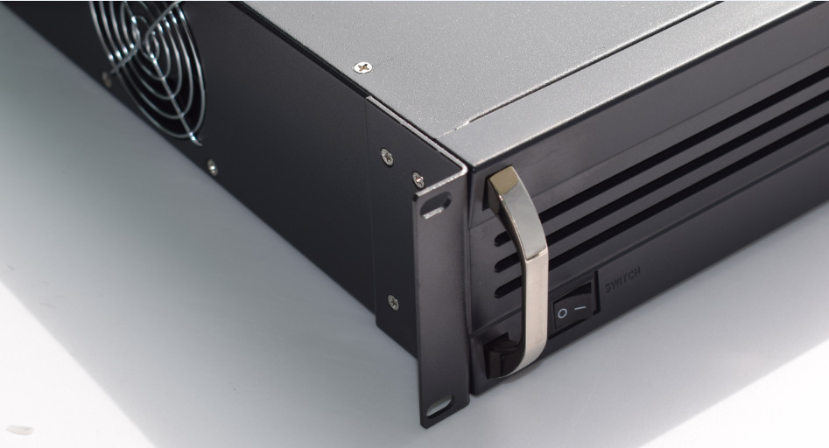


Contact Bwitt for data sheets and characterization details. Due to product development, specifications are subject to change without prior notice.
sales02@bwitt.com.cn WWW.BWITT.COM.CN/EN
Add:Floor 2, Building A13, The first industrial District, Yuquan east RD, guangming district, Shenzhen, Guangdong, China
Tel:+86 755 21007420 Fax:+86 755 2983220786 Phone:8615307200395

