


BWITT®
POWER SUPPLIER
MODULAR RACK MOUNT RECTIFIER SYSTEM
RCT-2000 SERIES

19 INCH MODULAR

RECTIFIER SYSTEM

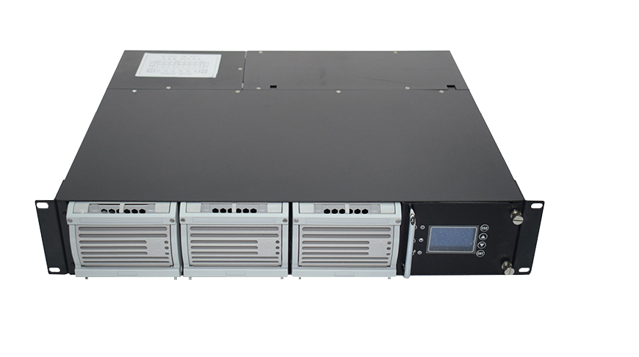
INPUT VOLTAGE 220VAC

OUTPUT VOLTAGE 26.7VDC

OUTPUT CAPACITY 3000W

BWT220/24-100AS
DESCRIPTION

Embedded DC Power System is widely deployed in the Telecom/Industrial environment today, a new generation “Green & Energy Saving” system, aiming at outdoor low power mobile Telecom/Industrial power market, meeting the trend of Telecom base station development, saving construction cost and shortening the time. The system is highly adaptable with the environment, features with a wide operating temperature range, meeting the demand of high-level users.

APPLICATION STANDARDS

Electrical | GB4943-2001 IEC 60950-1 IEC60950-1
EMI | EN 55032:2015 EN 55035:2017 EN61000-3-2:2014 EN55022, CLASS A
ESD | GB17626.2-1998/IEC61000-4-2
EFT | GB17626.4-1998/IEC61000-4-4
SURGE | GB17626.5-1998/IEC61000-4-5
DIP | GB17626.11-1998/IEC61000-4-11
Conducted Immunity | IEC61000-4-6
Radiated Immunity | IEC61000-4-3
Environment | ETSI EN 300 019-2 ETSI EN 300 132-2 RoHS


APPLICATION

FEATURE

- Wide operating range of AC input voltage: 90~290Vac;
- current/voltage switching tech with high efficiency ≥93.2%;
- Perfect battery management, battery temperature;
- Multiple communication ports, easy for networking and remote management.
- ModbusRS485 /TCP/IP/YDN23 (YD/T 1363) protocol;
- Temperature compensation, LVLD and LVBD protection;
- Automatic battery test function, cycle test, quick test;
- Supports power system &module sleep, efficiency mixing, energy saving;
- Support real-time detection of the operating status of the power system;
- Support alarm real-time detection and reporting;
- Hot-swap able;
- Input over/under voltage protection;
- Output over voltage protection;
- Output over current protection;
- Output short circuit protection;
- Auto current sharing, parallel operation;

- Satellite Communication Ground Station
- SCADA Networks and Data Room
- Mobile Communication
- Fiber Optic network
- Transmission equipment
- Radio base station/cell sites
- Railway & metro
- ESS
- 5G Base Station /Micro Base Station
- Direct-current emergency power units in power stations and chemical plants
MODULAR RECTIFIER SYSTEM

BWITT®
POWER SUPPLIER
TECHNICAL SPECIFICATION
 | BWT220/24-100AS
Rectifier Module | BR241800 2PCS
Efficiency | 93.2%
Power Capacity(Max) | 3000W
Input Current | 13.63A
Input Protection (Recom) | 17.04A
Height | 88mm(2RU)
Width | 482mm(19 Inch)
Depth | 410mm
Weight | 15KG Appro.
Classification | IP21

DC OUTPUT
Output Voltage | 21-29VDC  26.7Vdc nom.
Output Current(Max) | 110A
Equ- charge(V) | 28.2V(21-29Vdc adjustable);
Float voltage(V) | 26.7V(21-29Vdc adjustable);
Voltage Regulation | ≤±1%
Current Sharing | ≤±5%
PF | 0.99@220VAC/100A, ≥0.98@220VAC/50A;
Ripple voltage | ≤200mV<0-20mHZ>
Output Accuracy(V)） | ≤0.6%
Load Breaker | 3*32A@1P
Battery Breaker | 1*63A@2P
BLVD | Yes
Shunt | Yes

AC INPUT
AC Con-fig. | 220Vac (L+N+PE)
Input Voltage Range | 90Vac-290Vac
Frequency | 45-65Hz
THDi | ＜5%@ full load  ＜10% @half load  Rated input & Output Voltage
Mains Connection | 32A@2P

MODULAR RECTIFIER SYSTEM

BWITT®
POWER SUPPLIER

OTHERS
LCD display | Input/output voltage、Frequency、output current、Environment、Rate
Power status | City power、Output、Under voltage、overload voltage
Operating Temp. | -40 to +55°C (-40 to +131°F)
Storage temp | -40 to +70°C (-40 to +158°F)
Humidity | 5% to 95% RH non-condensing
MTBF | > 10,0000 hours (Ambience : 25°C)
Historical Alarm Records | Up to 1000 Units
Altitude（M） | ≤3000m,more than 3000m, Rise every 100m, Capacity derated 1% .
MONITOR CONTROL
Controller | M30.1.2V2&24
Digital Input | 6 DI
Local Interface | Display, Menu Structure Key Pads, LED
Remote Monitor | TCP/IP,Rs485,SNMP (Optional),6 alarm Relays
Battery Mid-Point | B-V2 /B-V1
User | 4 Group
intelligent Wake management | Yes
Battery Temp. Sensor | Yes
Temperature compensation | Yes
Battery Self-Test | Yes


Contact Bwitt for data sheets and characterization details. Due to product development, specifications are subject to change without prior notice.


Thomas@bwitt.com.cn WWW.BWITT.COM.CN/EN
Add:Bldg 8, Sunshine Industry Park, Xili town,Nanshan , Shenzhen , Guangdong, China
Tel:+86 755 21007420 Fax:+86 755 2983220786 Phone:8618822867573

